Day 20
Sprint 1 Submission
Name: Mriganka Patra
Emp ID: 2415820
Email: Mriganka.Patra@cognizant.com

Task:
Write and execute manual test cases for SharePoint forms.

Project Name | Day 20 Sprint  submission
Client | Flipkart
Created By | Name: Mriganka Patra
Creation Date | 2025-06-25
Approval Date | 22-06-25
Epic | Task | User Story ID | Features / Title | User Story | Status | Acceptance  Criteria
Employee Onboarding and IT Asset Management Portal | Write and execute manual test cases for SharePoint forms | D001 | Login | As a registered user, I want to login to the website so that I can check the SharePoint forms. | New | System must validate user credentials and allow login if credentials are correct
 |  | D002 | Field Check | As a user I have to provide all the mandatory fields otherwise the form won’t allow to be submitted. | New | Users have to fill up all mandatory fields to submit the form.
 |  | D003 | Data Type  Validation | As a user I cannot provide invalid information to the fields in the form. | New | Users can not provide invalid data.
 |  | D004 | Form  Submission | As a user I must be able to submit the form and the server must keep track of my submitted information. | New | User can submit forms.
 |  | D005 | Form  Cancellation | As a user I must be able to cancel a form submission if needed and my data should not be recorded in that case. | New | User can cancel forms.

Manual Test Cases:
Test Case 1: Form Validation - Required Field Check
Description: Verify that the form prevents submission when required fields are left blank and displays appropriate error messages.

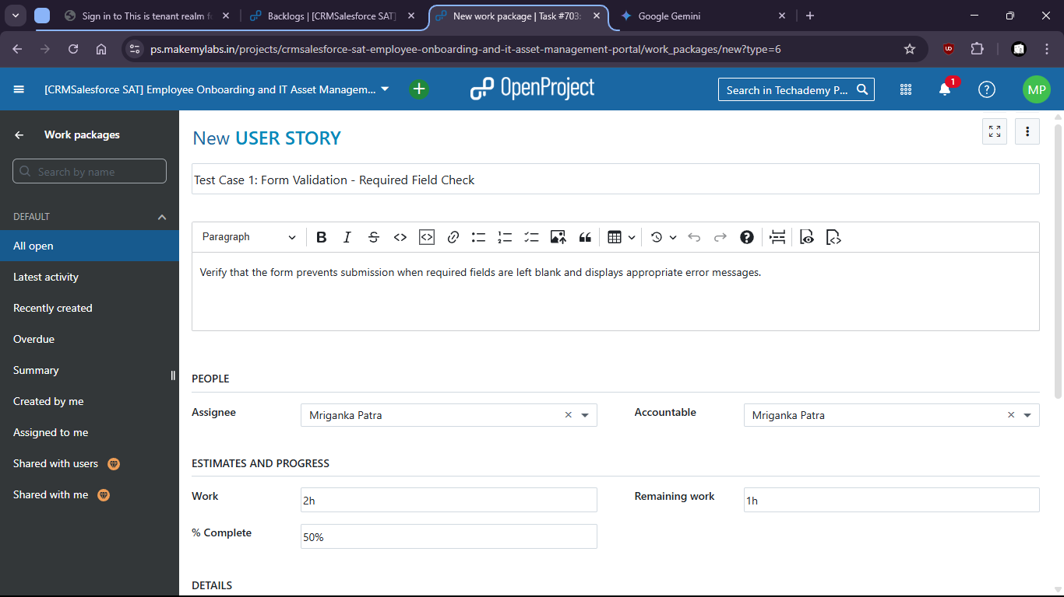
- Test for the SharePoint form if blank field shows any error.
- 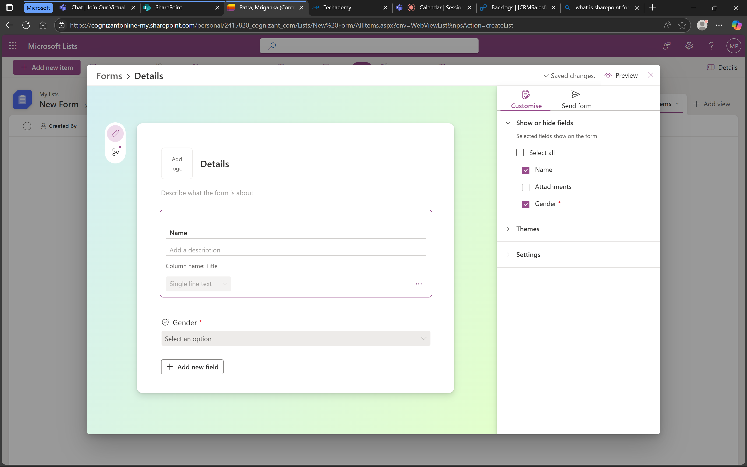

- When mandatory field gender is not filled it shows error message.
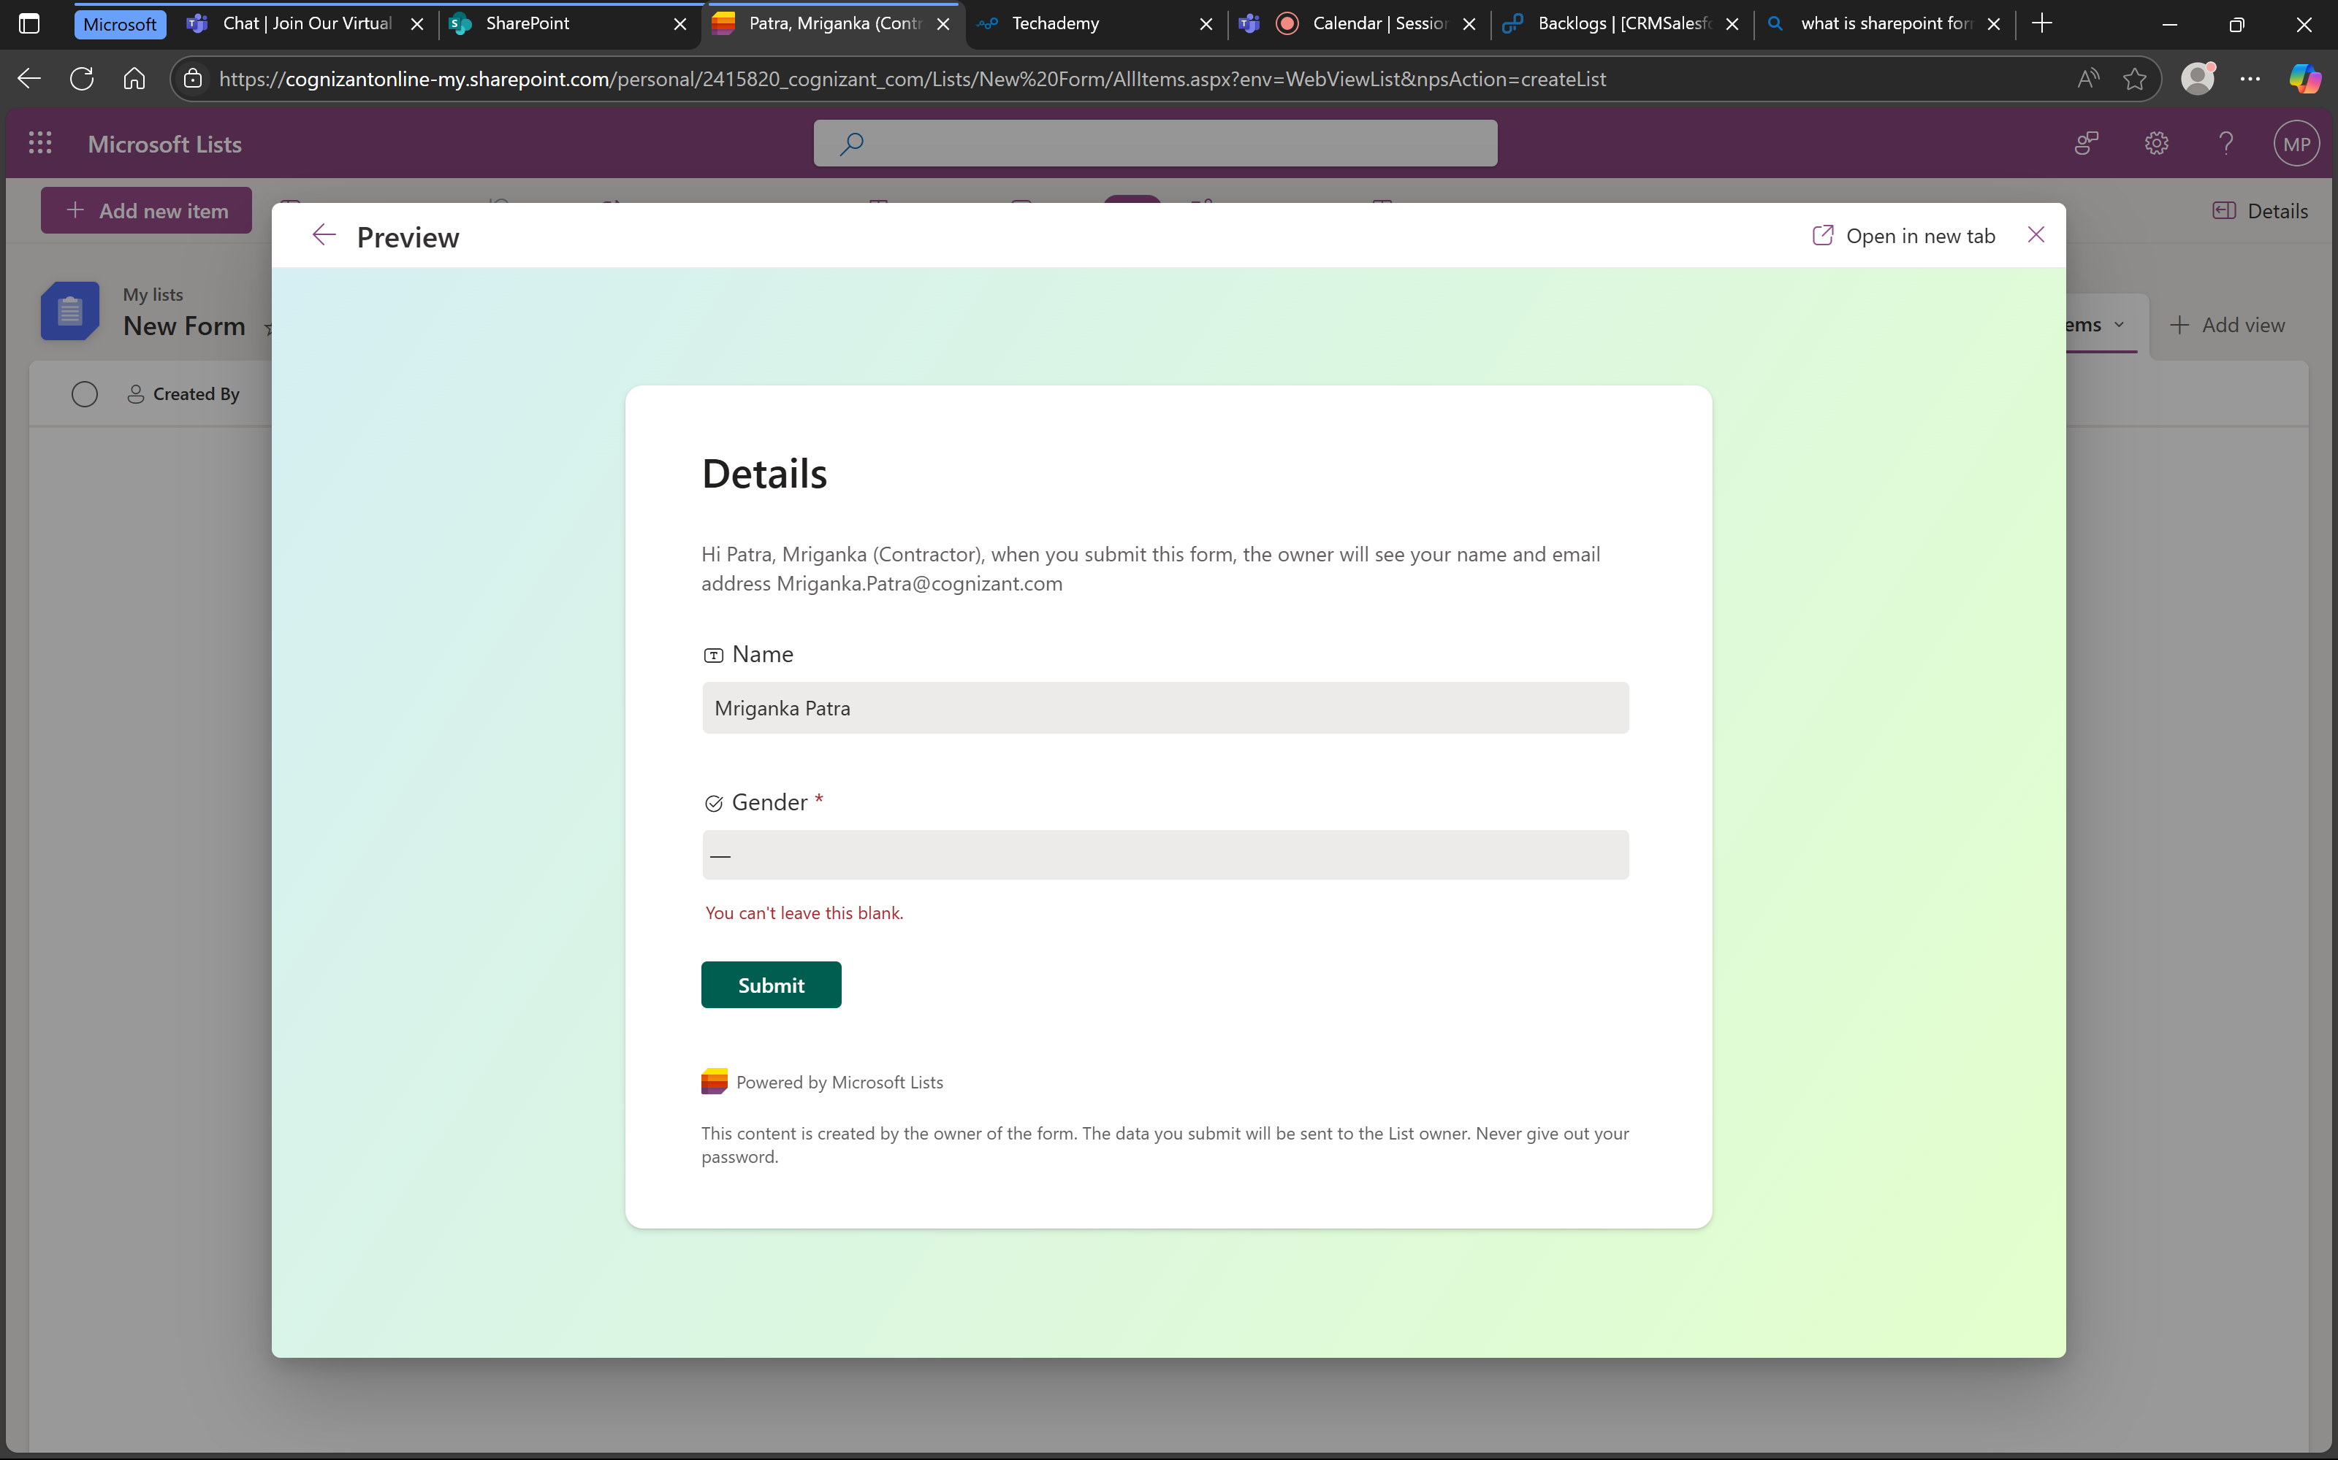

- Means that the form is working successfully.

Test Case 2: Data Type Validation - Invalid Input
Description: Verify that the form correctly validates input for specific data types (e.g., names, gender) and displays error messages for invalid entries.

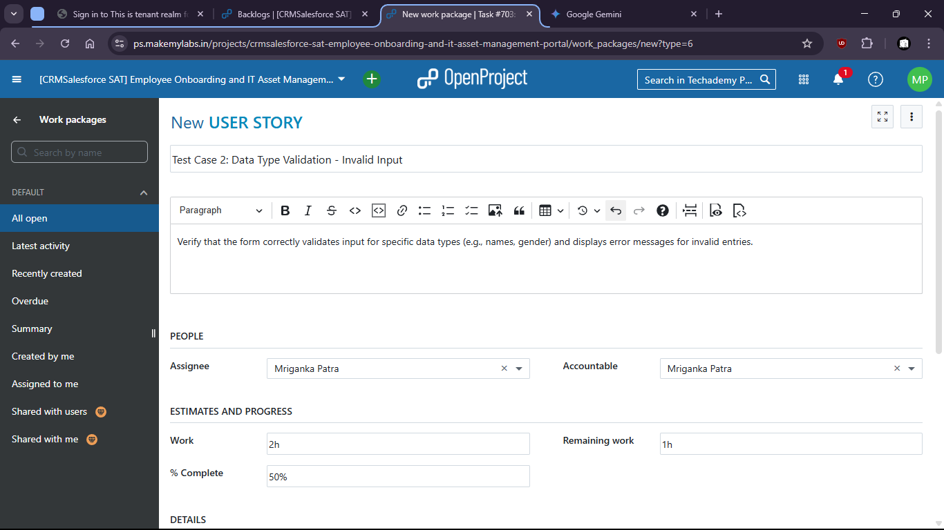

- There is no option to put invalid data and submit wrong format.
- Try to put invalid data in the filed like gender
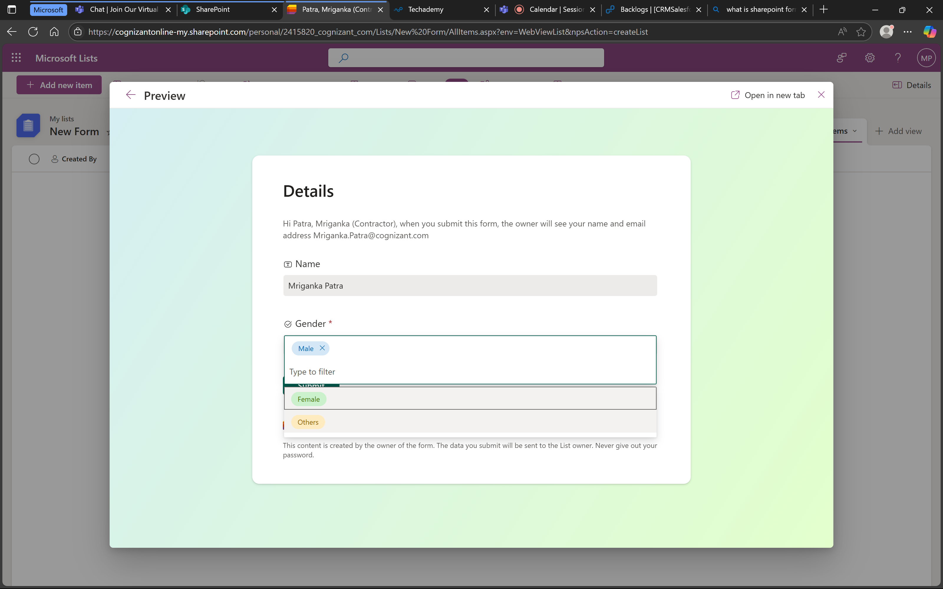
- There is no option to put invalid data.

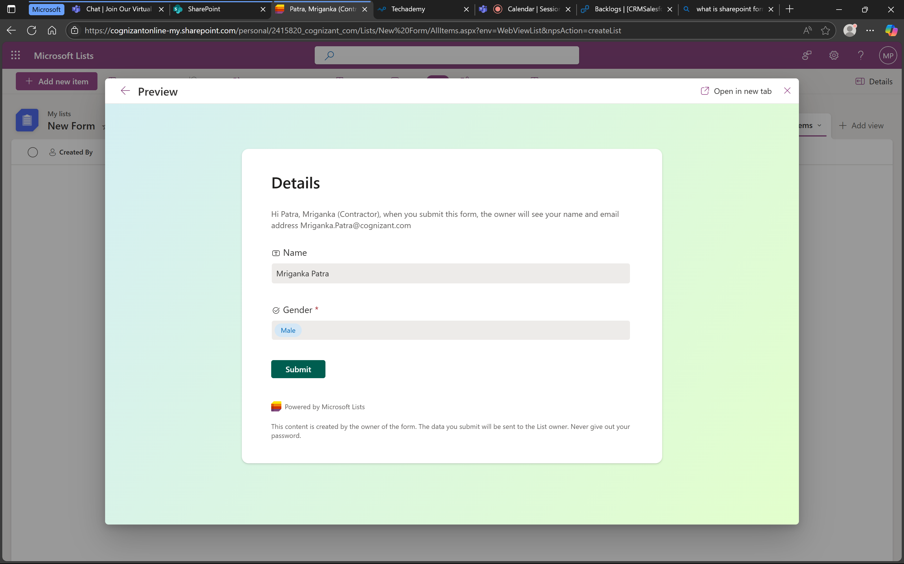
- That means the test is success and form is working as expected.
Test Case 3: Form Submission - Successful Submission
Description: Verify that a new item can be successfully created and saved through the SharePoint form.

- Check if the form is being submitted successfully.
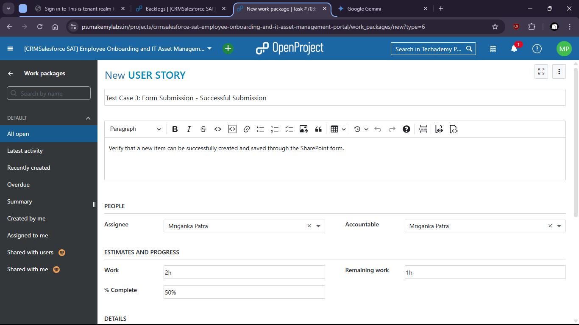

- Put valid data and submit the form.
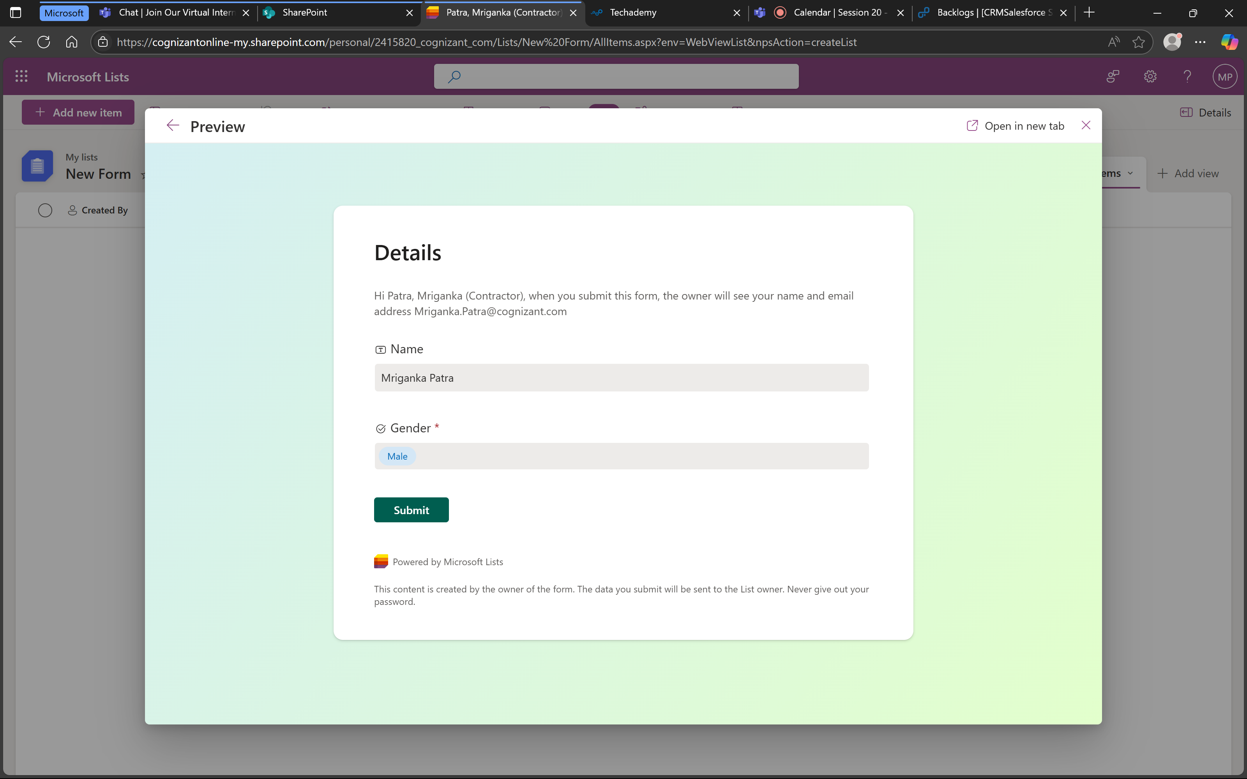

- Form is submitted.

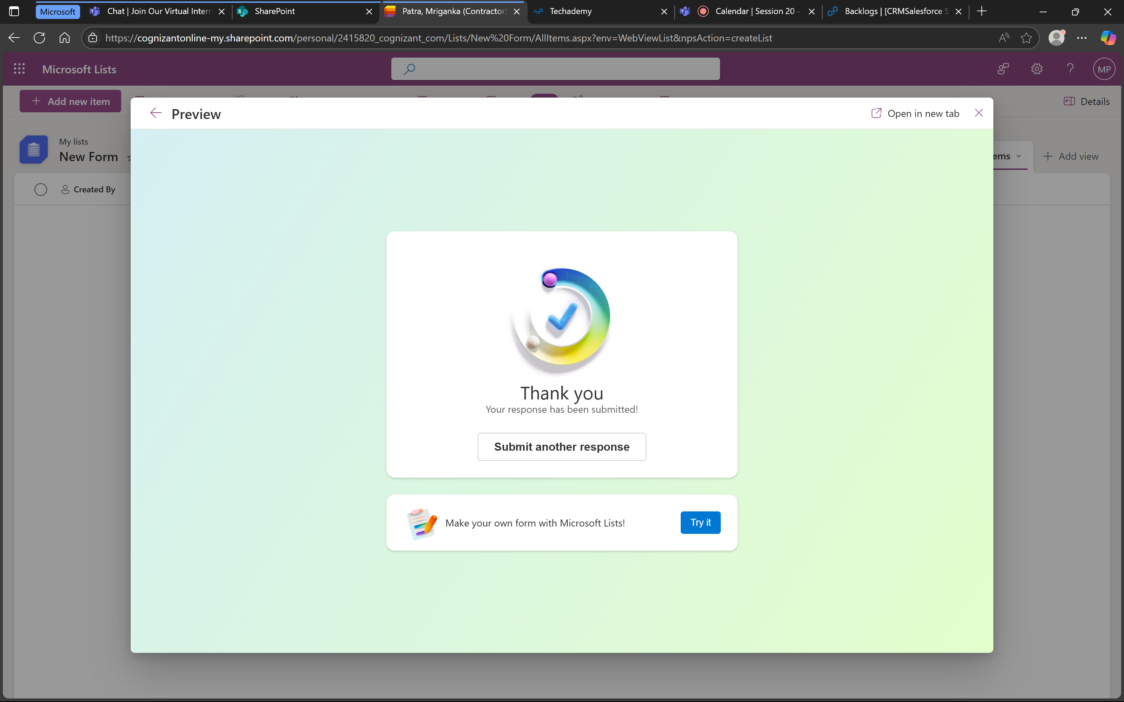

- Values are also stored successfully.
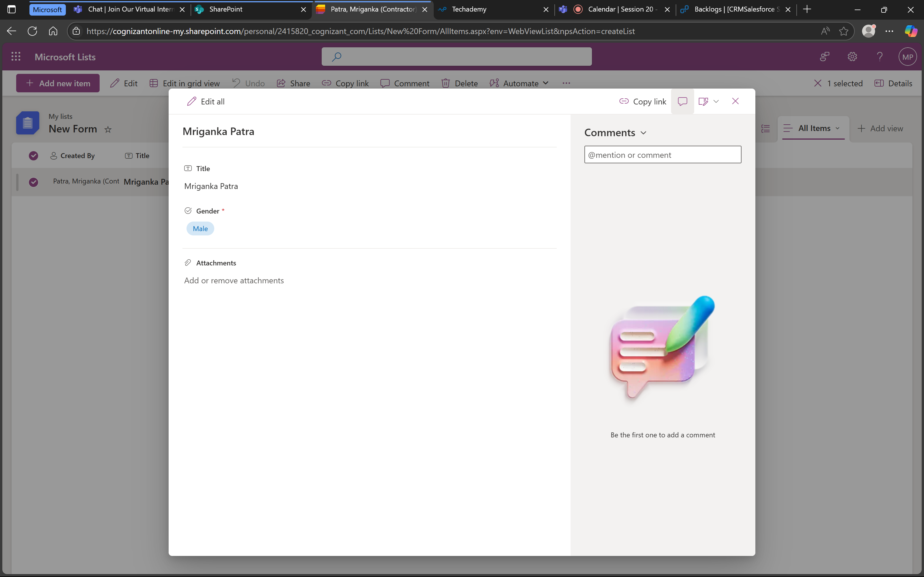

- That means the form is working successfully.

Test Case 4: Form Cancellation
Description: Verify that the form can be cancelled without creating an item.

- Check if after cancellation the data is being cleared.
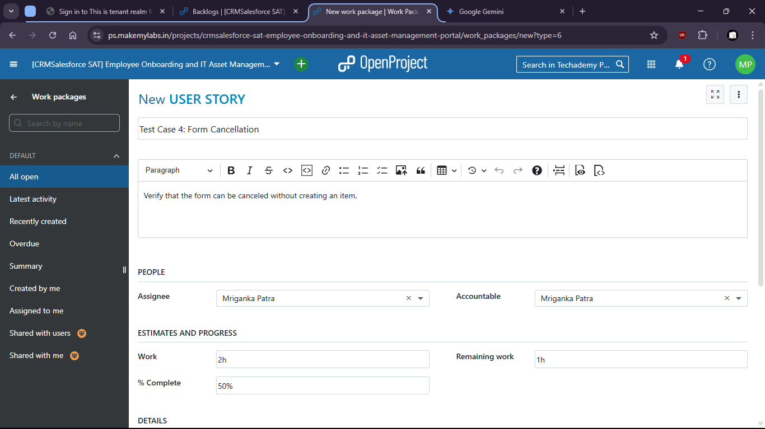

- Form is filled up
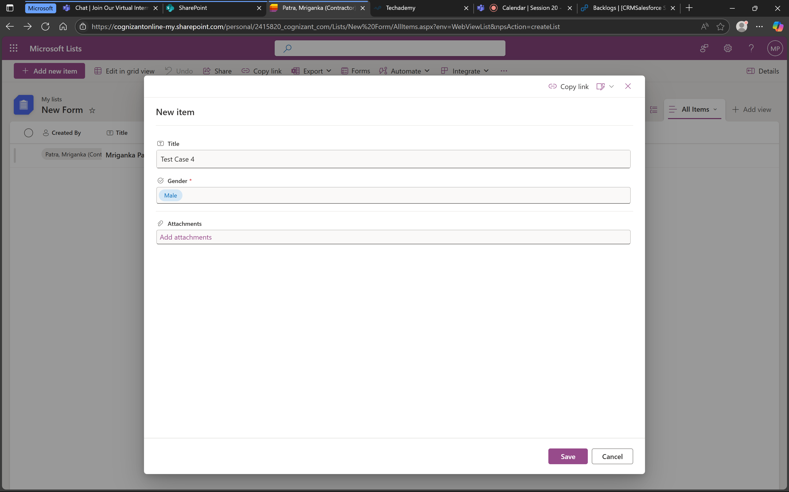

- Then it is cancelled:
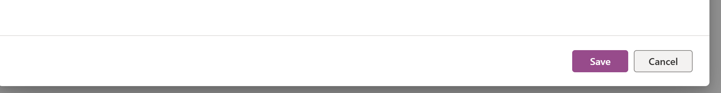

- We can check that no new form is created

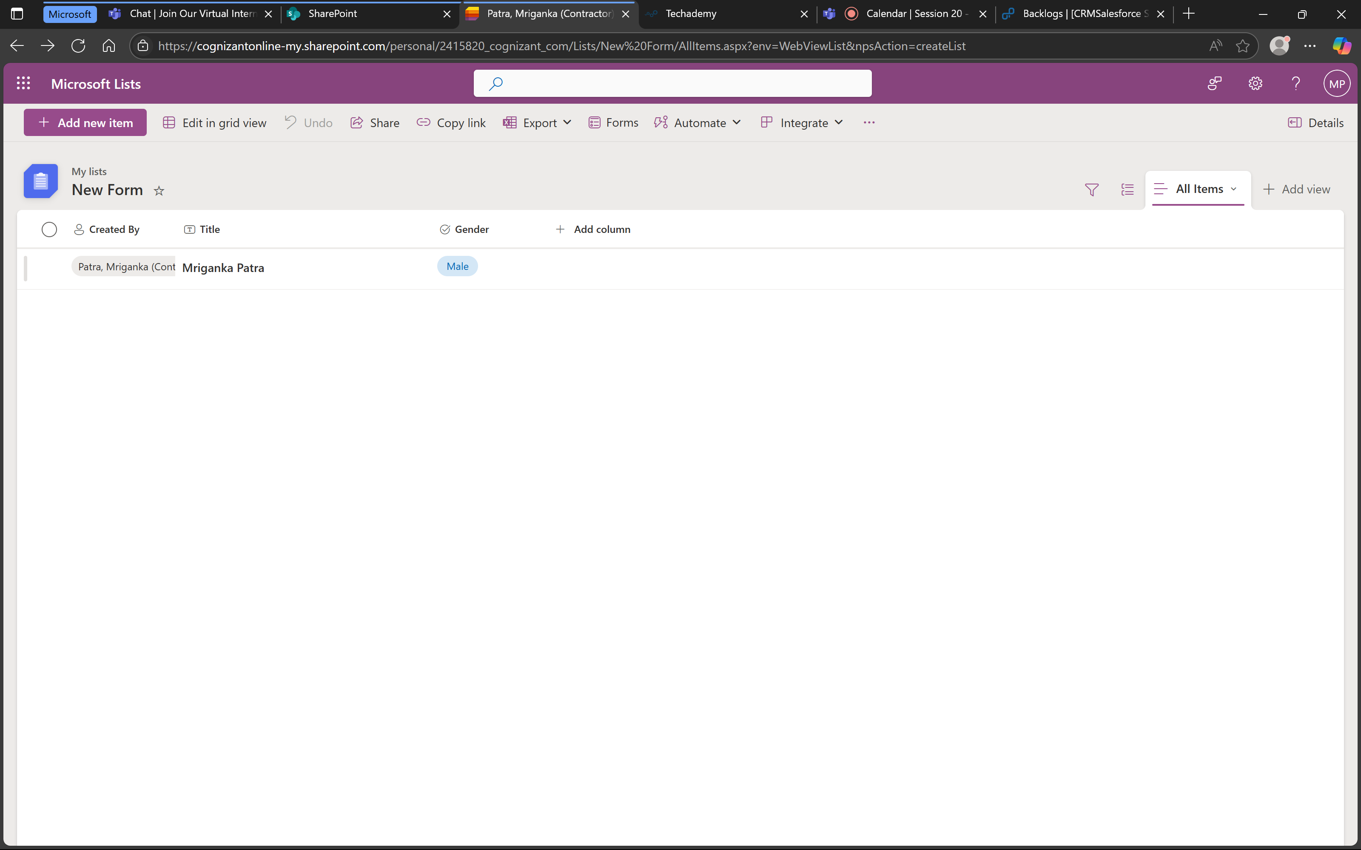

- That means the form does not store values after cancellation and is working as expected.

Under epic > task created and assigned (703)
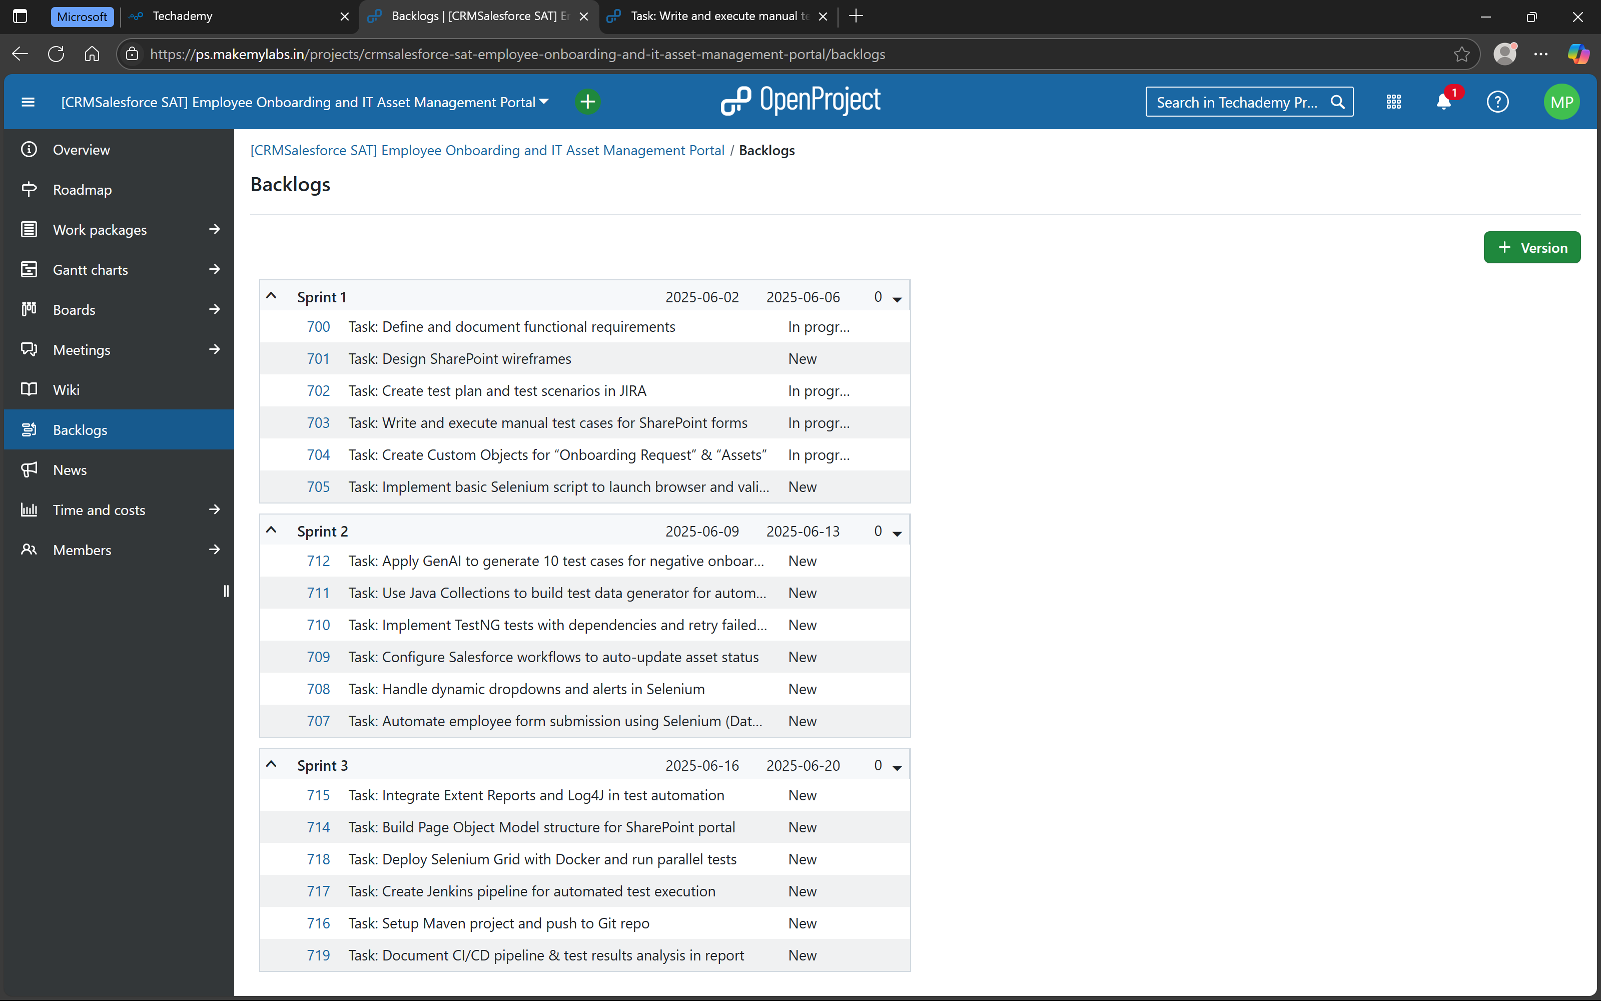

Under Task > user stories created and completed (with hierarchy)

